Car game

Game play-

* Ammo is replenished upon completing a lap
* Hardcore vs. core physics
* Clan tag on license plate
* Interactive environment/bots
* Co-op game mode: driver + passenger (caters to social gaming crowds).
* Survival (zombies chase, elimation, no teams: kill anyone or work together)
* Arms race (start with no weapons, get a better weapon at each checkpoint)
* Maps have multiple routes, all of which are constantly changing

Each car has different stats-

1. Acceleration
2. Max speed(v)
3. Traction
4. No2
5. Health
6. Weight

Physics:

Turning R = v^2/g(Mu)

Turning (Bank) R = v^2/gx

Higher R 🡪 lower sensitivity at said speed.

V/(2(pi)R) = Degrees/360

V = velocity, g = constant, (Mu) = multiplier for traction, higher is better.

(Mu) is found by multiplying car traction (Mu) by ground (Mu) (mud is bad, etc).

No2 = Force(constant)/mass

Landmine Jumping—take heavy damage, get mad hops

Speed(max) = (Speed(x)^2 + Speed(y)^2)^(1/2)

Momentum(x) = Speed(x) \* Weight

Momentum(y) = Speed(y) \* Weight

During Collsion(1-2): [Momentum(x2) + Momentum(x2)] Weight(1+2) = Speed(x)

During Collsion(1-2): [Momentum(y2) + Momentum(y2)] Weight(1+2) = Speed(y)

PostCollisionSpeed = (Speed(x)^2 + Speed(y)^2)^(1/2)(Weight)

PostCollisionDamage = [Speed(initial) – speed(final)]\*Constant

Walls: Treat Weight As infinitely High, thus speed will instantly go to zero.

Defensive weaponry- Controlled by driver

1. Oil(makes the cars traction bad for a period of time)
2. Caltrops(does damage to the car overtime)
3. Smoke(blinds the car)
4. Landmine(explodes on impact, can be upgraded to propel from bottom of car-cause massive damage)
5. Gravity lift(propels the car into the air)
6. Teleporter(sends car back certain amount of feet)

Offensive weaponry-Controlled by Passenger

1. Browningx2(light, 300) 2 points
2. Browningx2(moves left and right, light, 300) 2 points
3. Vulcan(mounted, heavy, 500) 5 points
4. Rocket launcher(mounted, heavy, 10) 5 points
5. Mini rocket launcher(medium, 20) 4 points
6. Grenade launcher(medium, 30) 3 points
7. Chainsaw(underneath, medium, 1) 3 points
8. SSM missiles(mounted on back, heavy, 4) 6 points
9. Tow missile(mounted, heavy, 5) 6 points
10. Burrow missile(shoots heat seeking missile from bottom of car, can only be used when car is lifted in the air, 1) 4 points
11. MG 42x2(moves left and right, up and down, light, 300) 2 points

Armor types-

1. Weak(move fastest)
2. Medium(move slower, increase health/weight) (+50hp) (-5mph) (+1000lb)
3. Heavy(move slowest, increase health/weight more) (+100hp) (-10mph) (+2000lb)

Cars-

1. 2007 Dodge Charger SRT8 Super Bee
2. Lamborghini Diablo
3. 356A Porsche
4. Ford F150
5. Jaguar XJ 220
6. Ferrari
7. 2006 Acura RSX coupe
8. Hum V

Car stats-

1. 2007 Dodge Charger SRT8 Super Bee-
2. Acceleration: 0-60 in 5.0sec, 0-100 in 11.6sec
3. Max Speed(v): 165mph (200mph)
4. Traction: stable, takes 324ft to slow down from 135mph
5. No2: 200000/weight, 5sec use, 20sec recharge, cannot use until No2 is full.
6. Health: muscle car(425hp)(500hp)
7. Weight: 4168lb
8. Lamborghini Diablo-
9. Acceleration: 0-60 in 4.5sec, 0-100 in 9.3sec
10. Max Speed(v): 202mph
11. Traction: good grip, cornering ability, crappy agility
12. No2: 200000/weight, 5sec use, 20sec recharge, cannot use until No2 is full.
13. Health: super car(492hp)(490hp)
14. Weight: 3564lb
15. 356A Porsche-
16. Acceleration: 0-60 in 13.50sec
17. Max Speed(v): 110pmh (185mph)
18. Traction: outstanding road handling
19. No2: 200000/weight, 5sec use, 20sec recharge, cannot use until No2 is full.
20. Health: sports car(95hp)(410hp)
21. Weight: 2000lb
22. Ford F150-
23. Acceleration: 0-60 in 8.9sec
24. Max Speed(v): 105mph (195mph)
25. Traction: takes 150ft to slow from 60ft
26. No2: 200000/weight, 5sec use, 20sec recharge, cannot use until No2 is full.
27. Health: pickup(420hp)(550hp)
28. Weight: 4980lb
29. Jaguar XJ 220-
30. Acceleration: 0-60 in 4.9sec
31. Max Speed(v): 198mph
32. Traction: agile handling
33. No2: 200000/weight, 5sec use, 20sec recharge, cannot use until No2 is full.
34. Health: super car(450hp)(450hp)
35. Weight: 3885lb
36. Ferrari-
37. Acceleration: 0-60 in 3.7sec
38. Max Speed(v): 205mph
39. Traction: excellent grip
40. No2: 200000/weight, 5sec use, 20sec recharge, cannot use until No2 is full.
41. Health: exotic(620hp)(400hp)
42. Weight: 3486lb
43. 2006 Acura RSX Coupe-
44. Acceleration: 0-60 in 7.1sec, 0-100 in 18sec
45. Max Speed(v): 155mph (193mph)
46. Traction: nimble handling, takes 170ft to slow from 60mph
47. No2: 200000/weight, 5sec use, 20sec recharge, cannot use until No2 is full.
48. Health: sports car(255hp)(430hp)
49. Weight: 2840lb
50. Hum V-
51. Acceleration: 0-60 in 7.9sec
52. Max Speed(v): 65mph (190mph)
53. Traction: all terrain, great traction
54. No2: 200000/weight, 5sec use, 20sec recharge, cannot use until No2 is full.
55. Health: armored car(190hp) (600hp)
56. Weight: 5200lb

ART:

2007 Dodge Charger SRT8 Super Bee

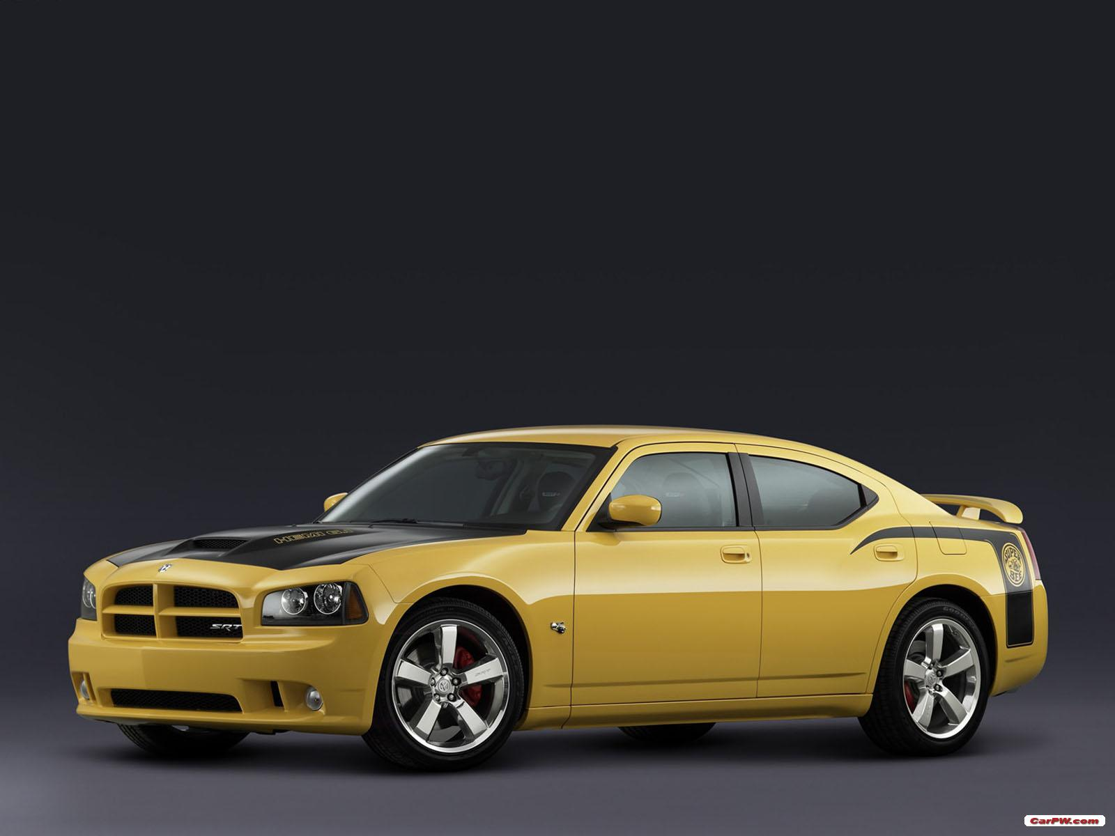

Lamborghini Diablo

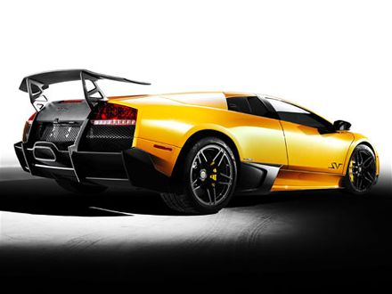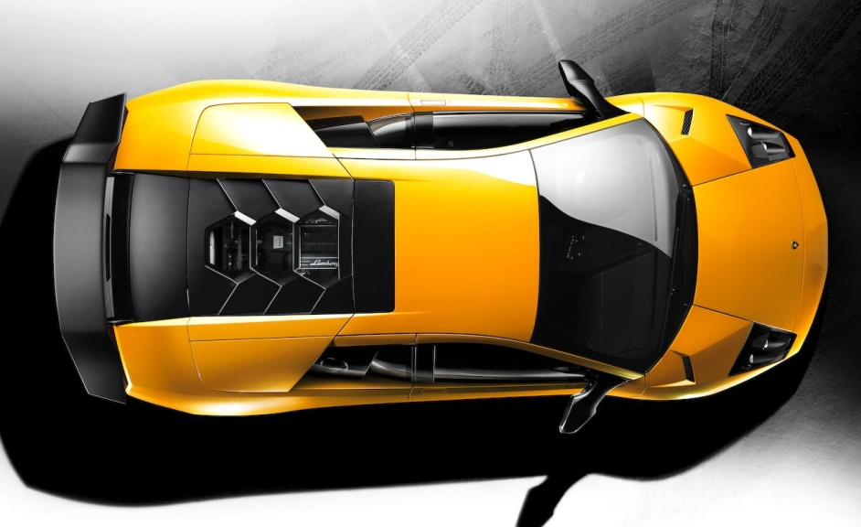

356A Porsche

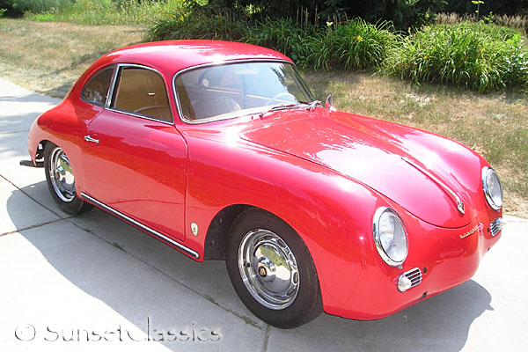

Ford F150

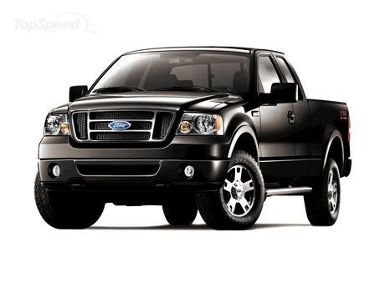

Jaguar XJ 220

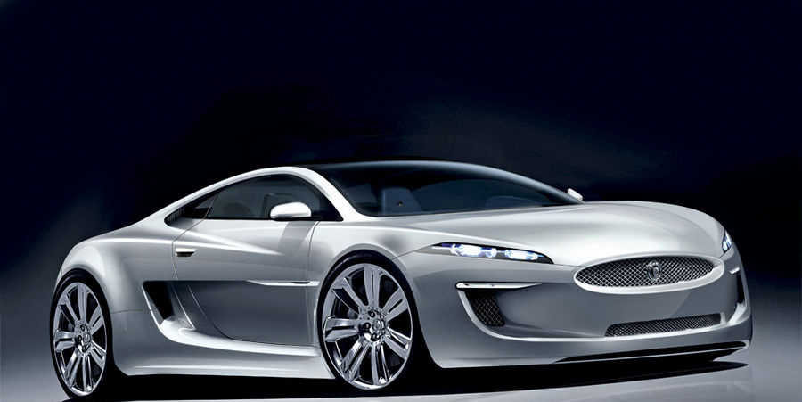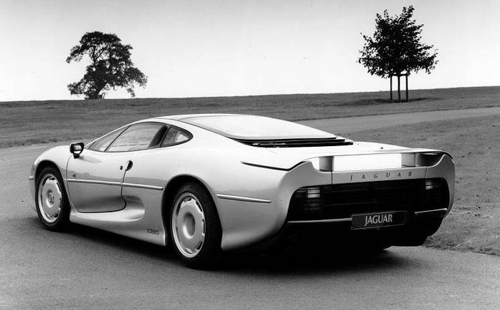

Ferrari

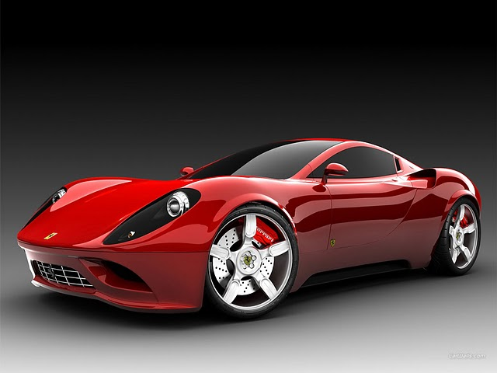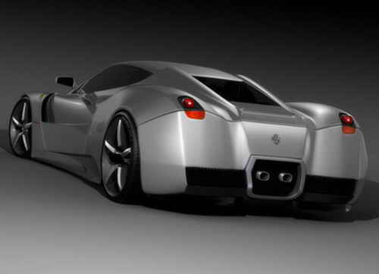

2006 Acura RSX Coupe

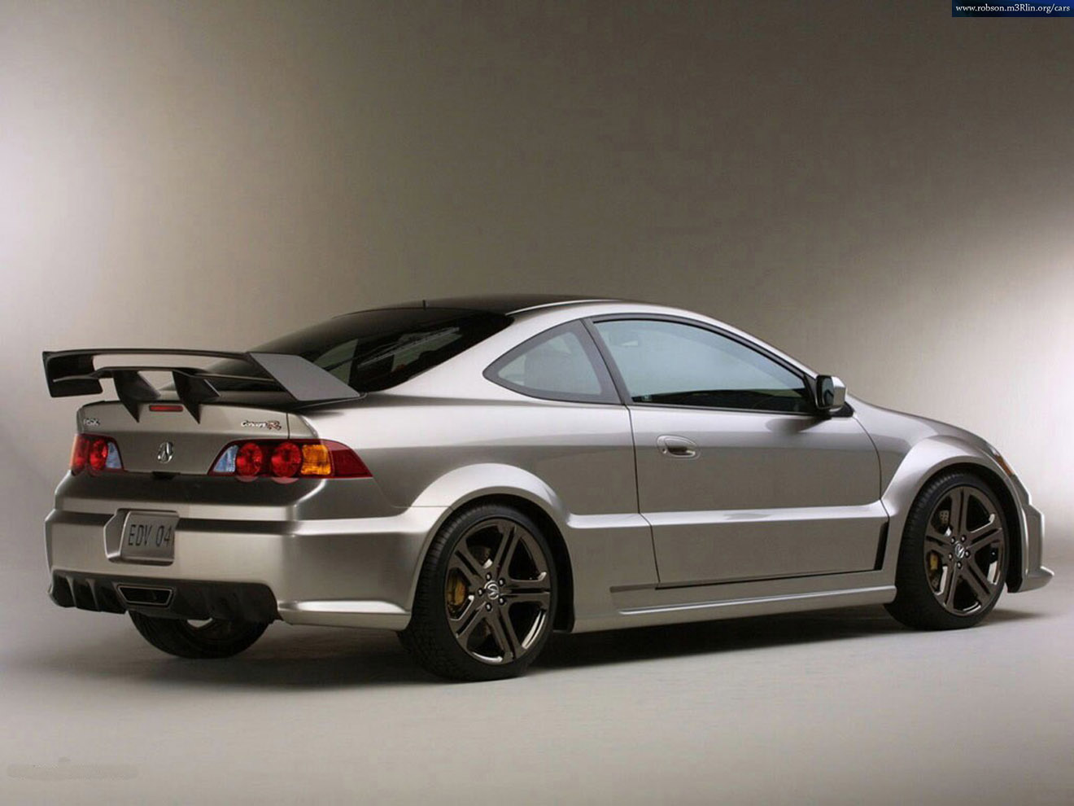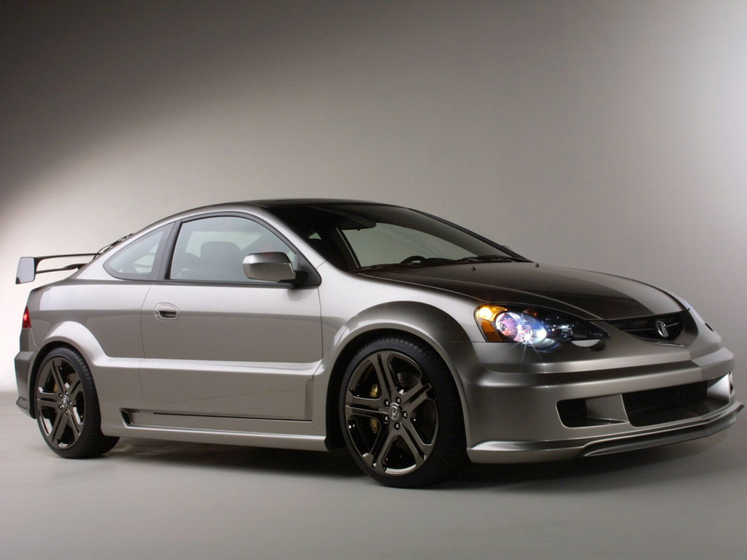

Hum V

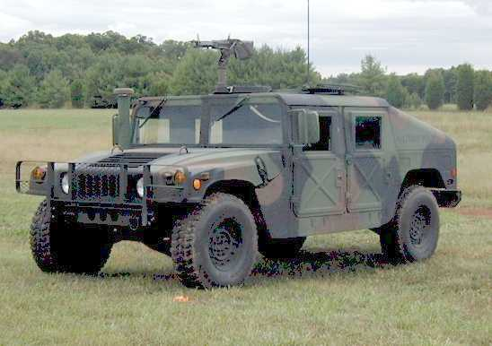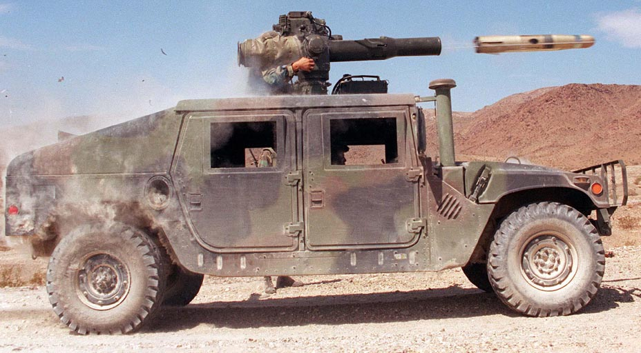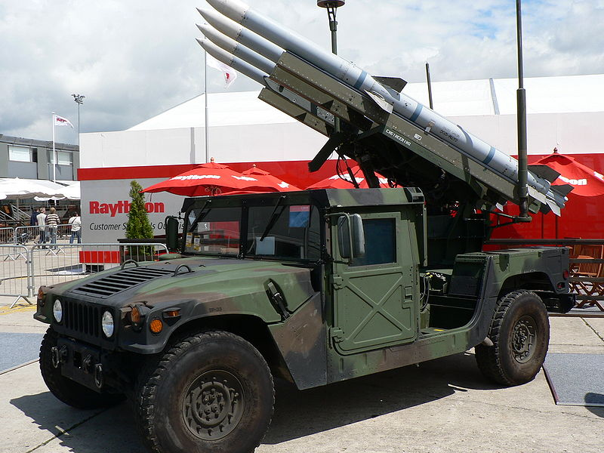

Browning

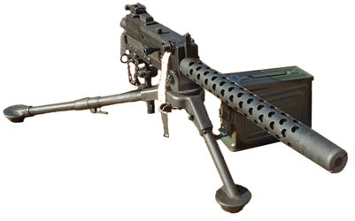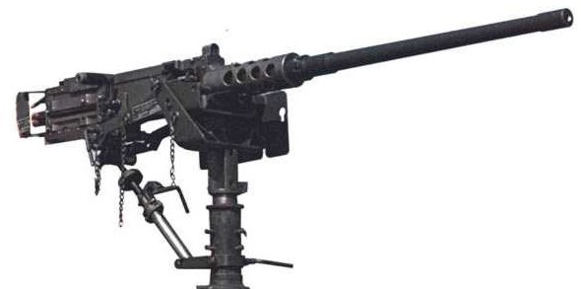

Vulcan

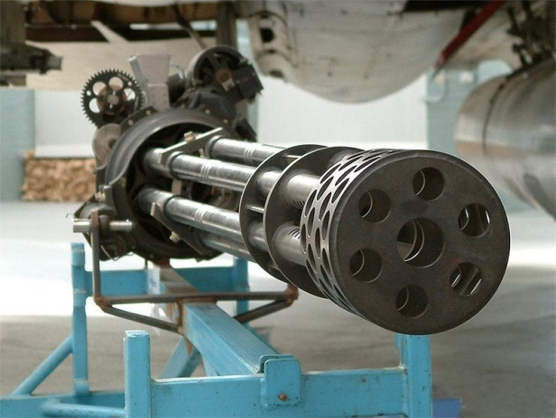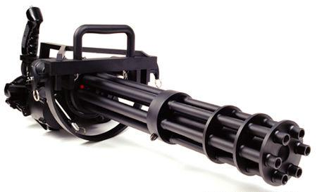

Rocket launcher

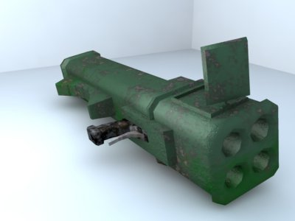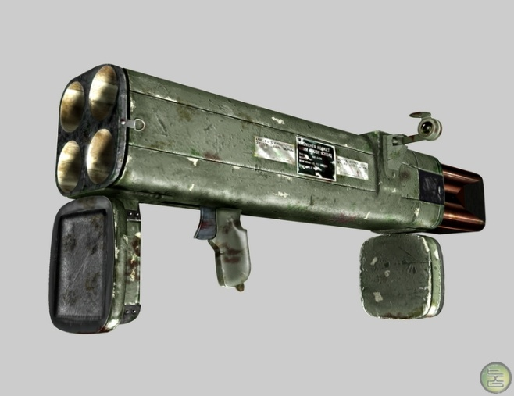

Mini rocket launcher

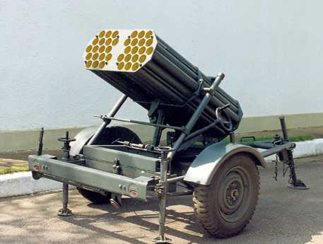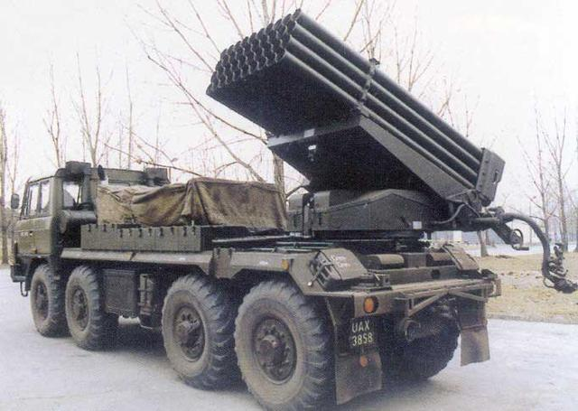

Grenade launcher

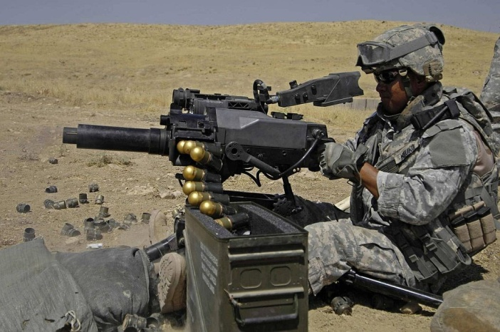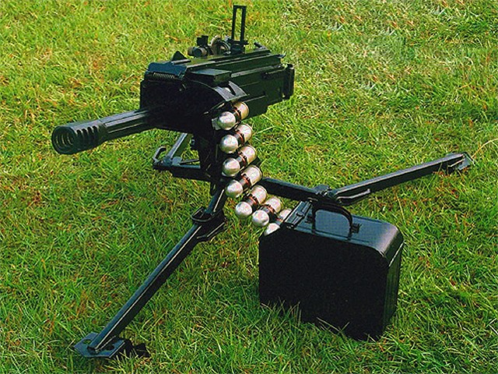

Chainsaw

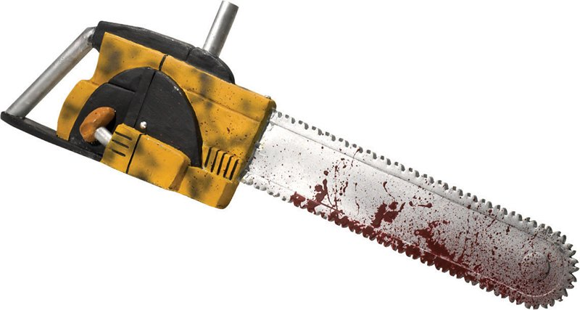

SSM missiles

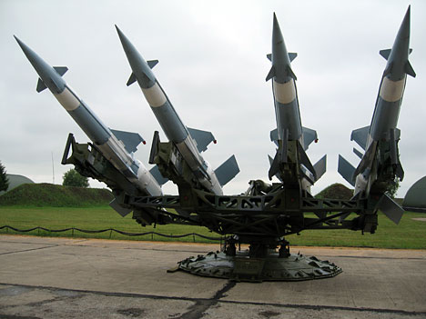

Tow missile

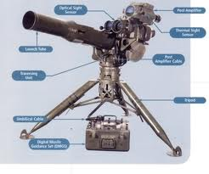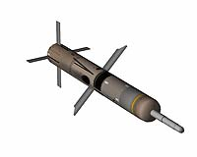

Burrow missile

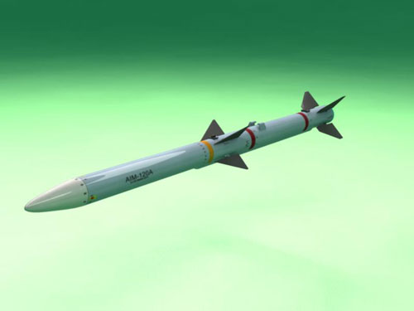

MG 42

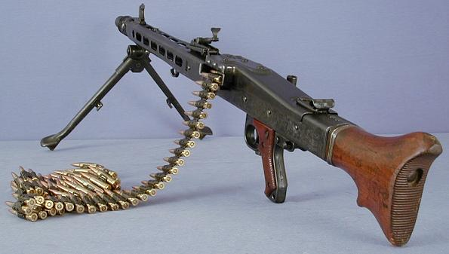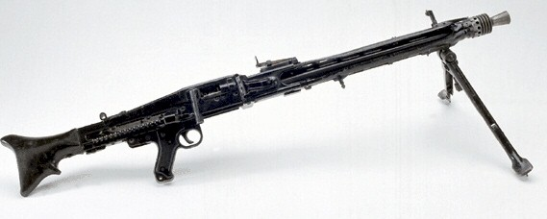

Oil

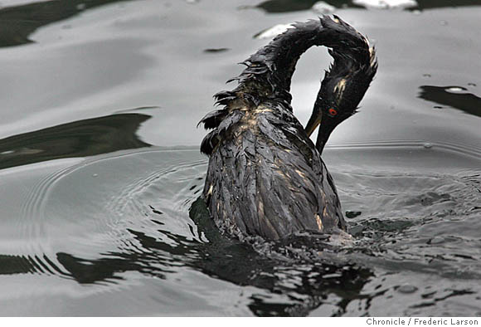

Caltrops

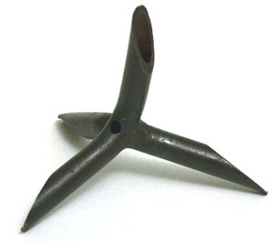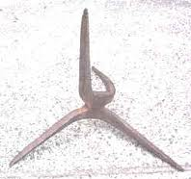

Smoke



Landmine

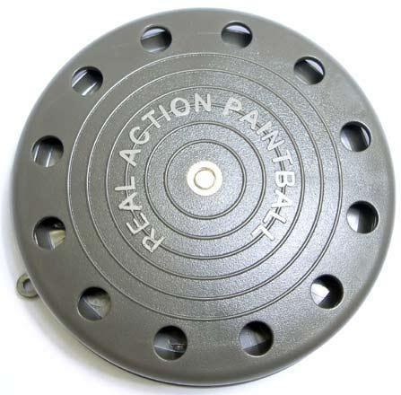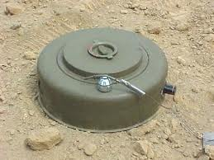

Gravity lift

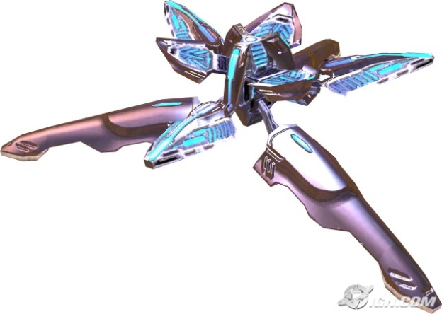

Teleporter

